For this exercise I'll configure Azure Monitor VM Insights to complete the process.

In this unit, I will:

1. Create a Log Analytics workspace.
2. Configure the Log Analytics workspace permissions model for the environment you're supporting.
3. Create two virtual machines and onboard both to Azure Monitor VM Insights.

**Create and configure a Log Analytics workspace**

1. In the [Azure portal](https://portal.azure.com/learn.docs.microsoft.com), search for and select **Log Analytics Workspace**.
2. Select **Create**.
3. Enter the following values to build the Log Analytics workspace. For the Log Analytics workspace name, we suggest that you use your initials and numbers. For this module, we will use the name *xxxx-log-analytics*.

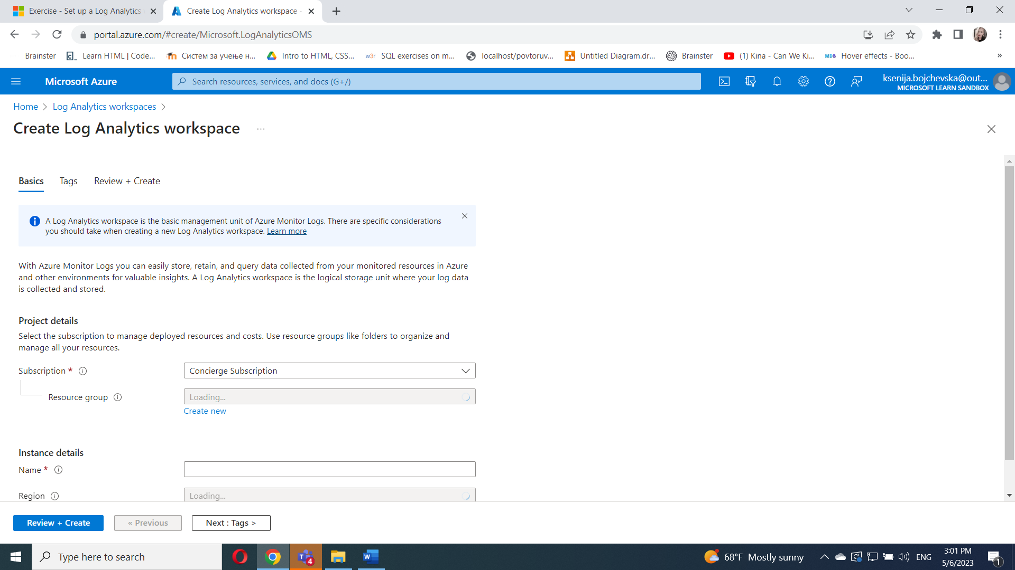

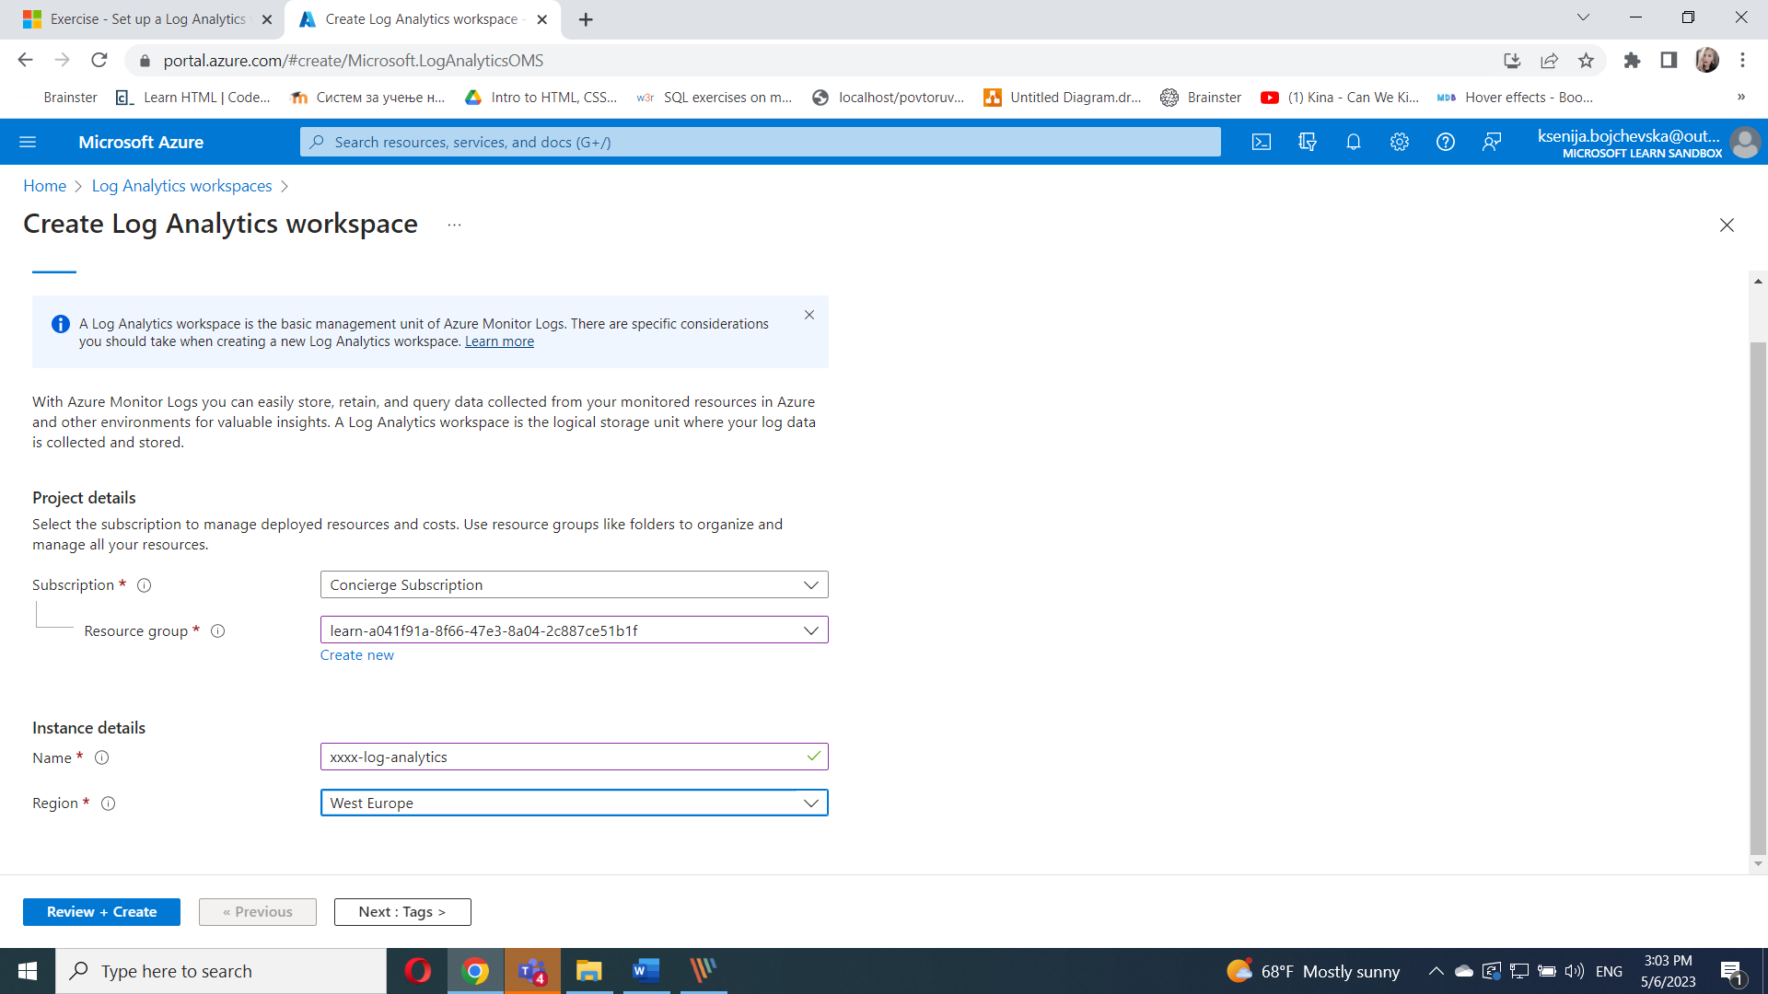

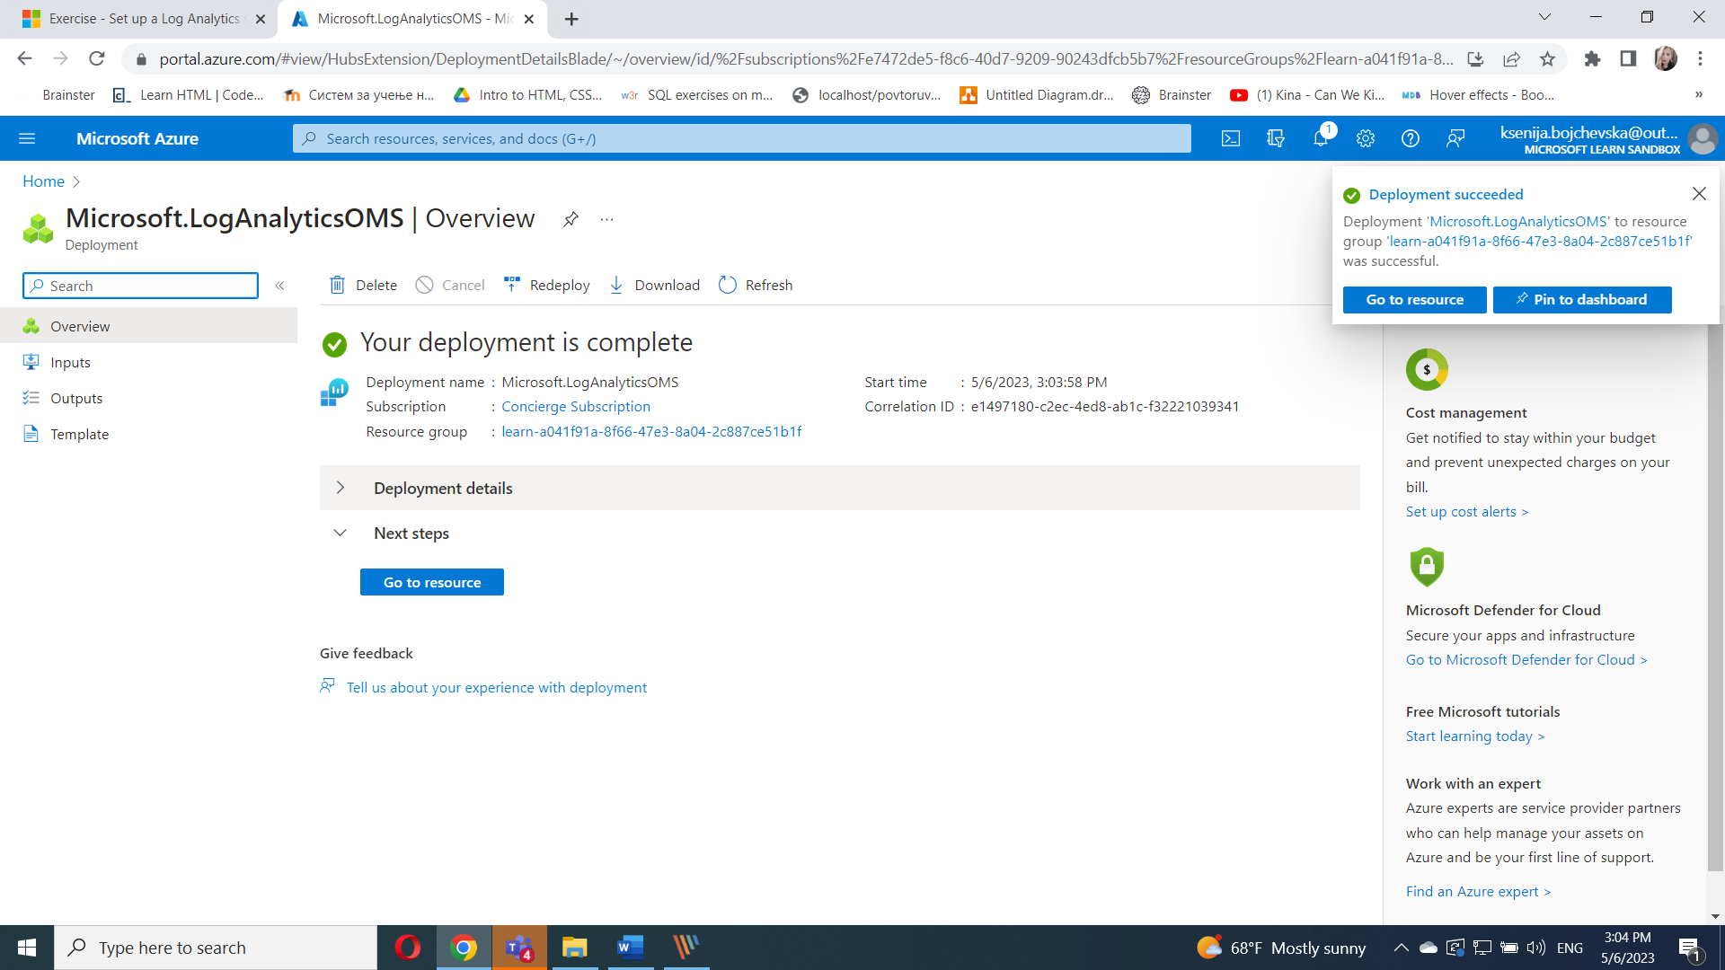

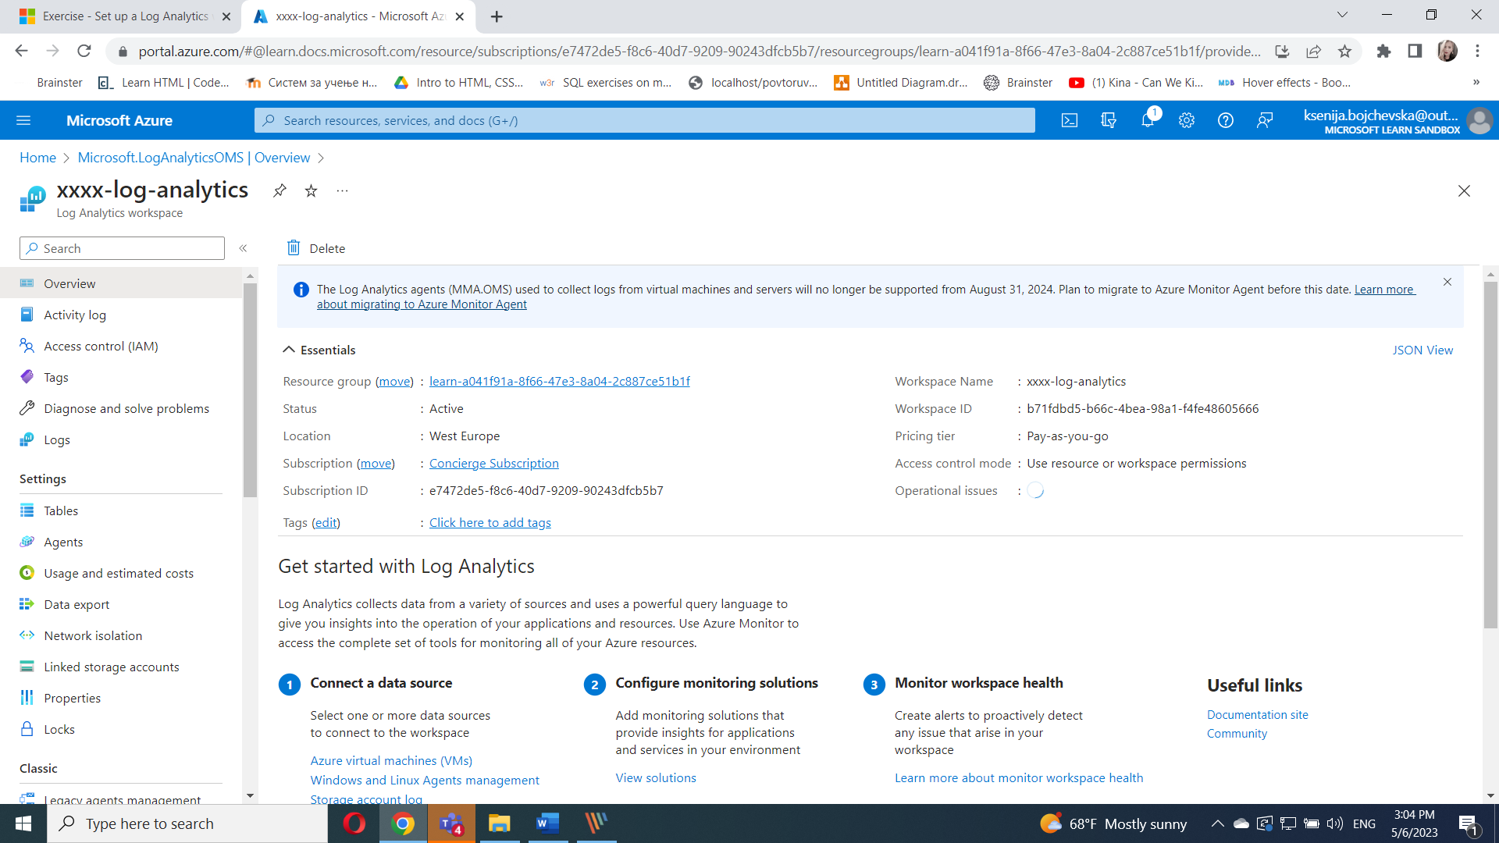

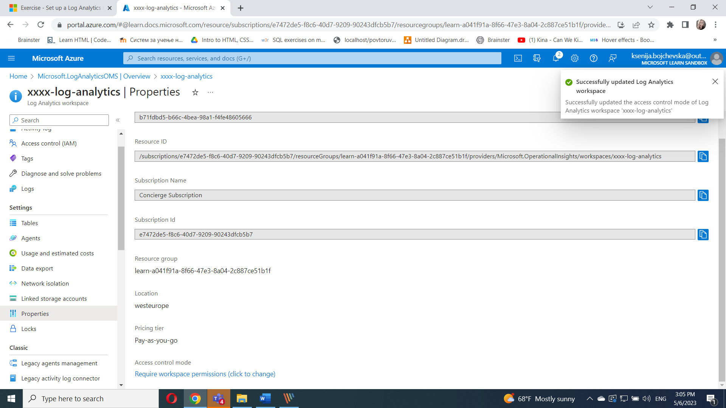

## Set up your environment

1. Run the following command in Azure Cloud Shell:

az vm create \

--resource-group learn-a041f91a-8f66-47e3-8a04-2c887ce51b1f \

--location westus \

--name SampleVM1 \

--image UbuntuLTS \

--admin-username azureuser \

--generate-ssh-keys \

--verbose

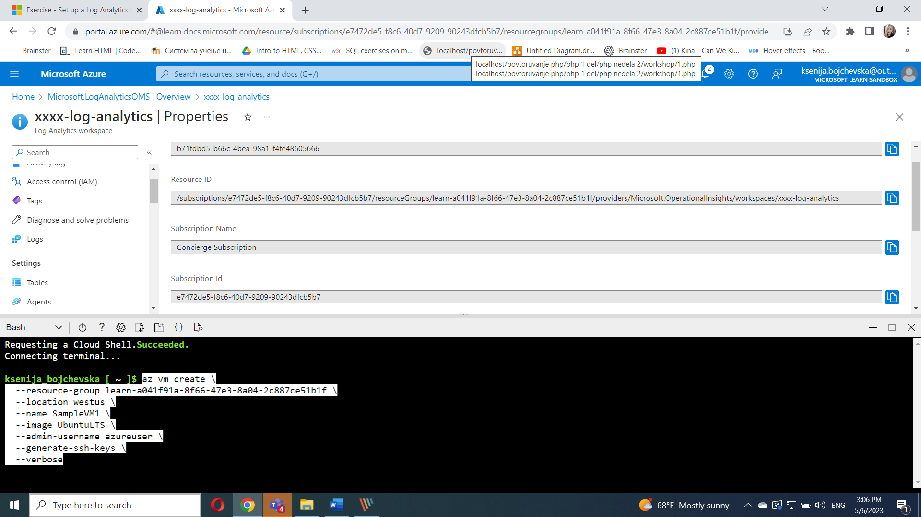

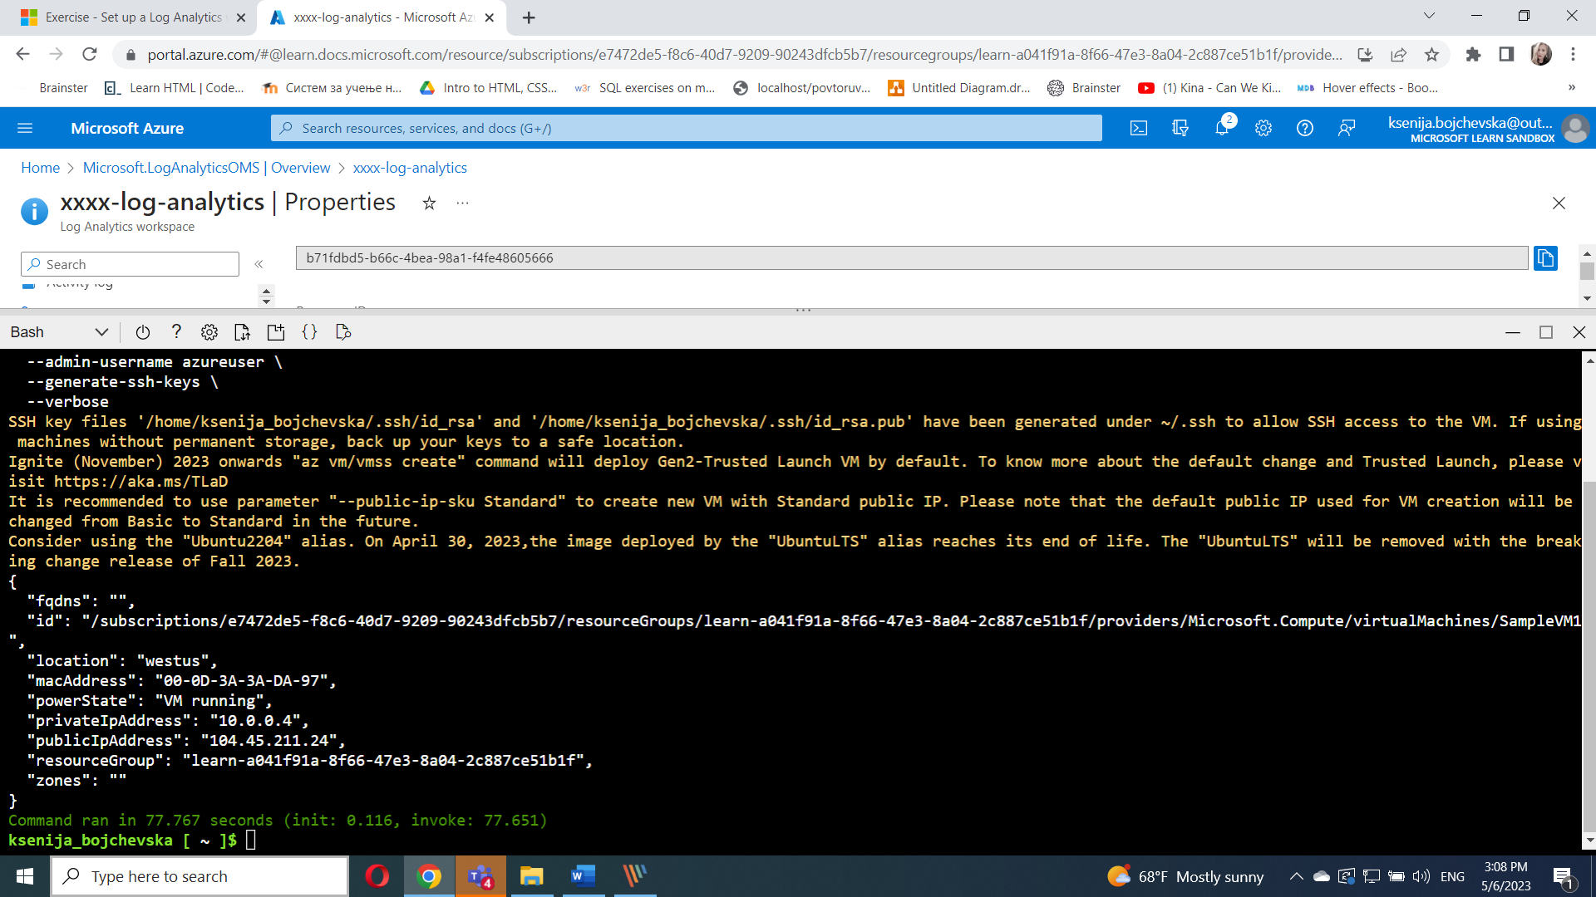

After SampleVM1 finishes, run the following command in Azure Cloud Shell:

az vm create \

--resource-group learn-a041f91a-8f66-47e3-8a04-2c887ce51b1f \

--location westus \

--name SampleVM2 \

--image UbuntuLTS \

--admin-username azureuser \

--generate-ssh-keys \

--verbose

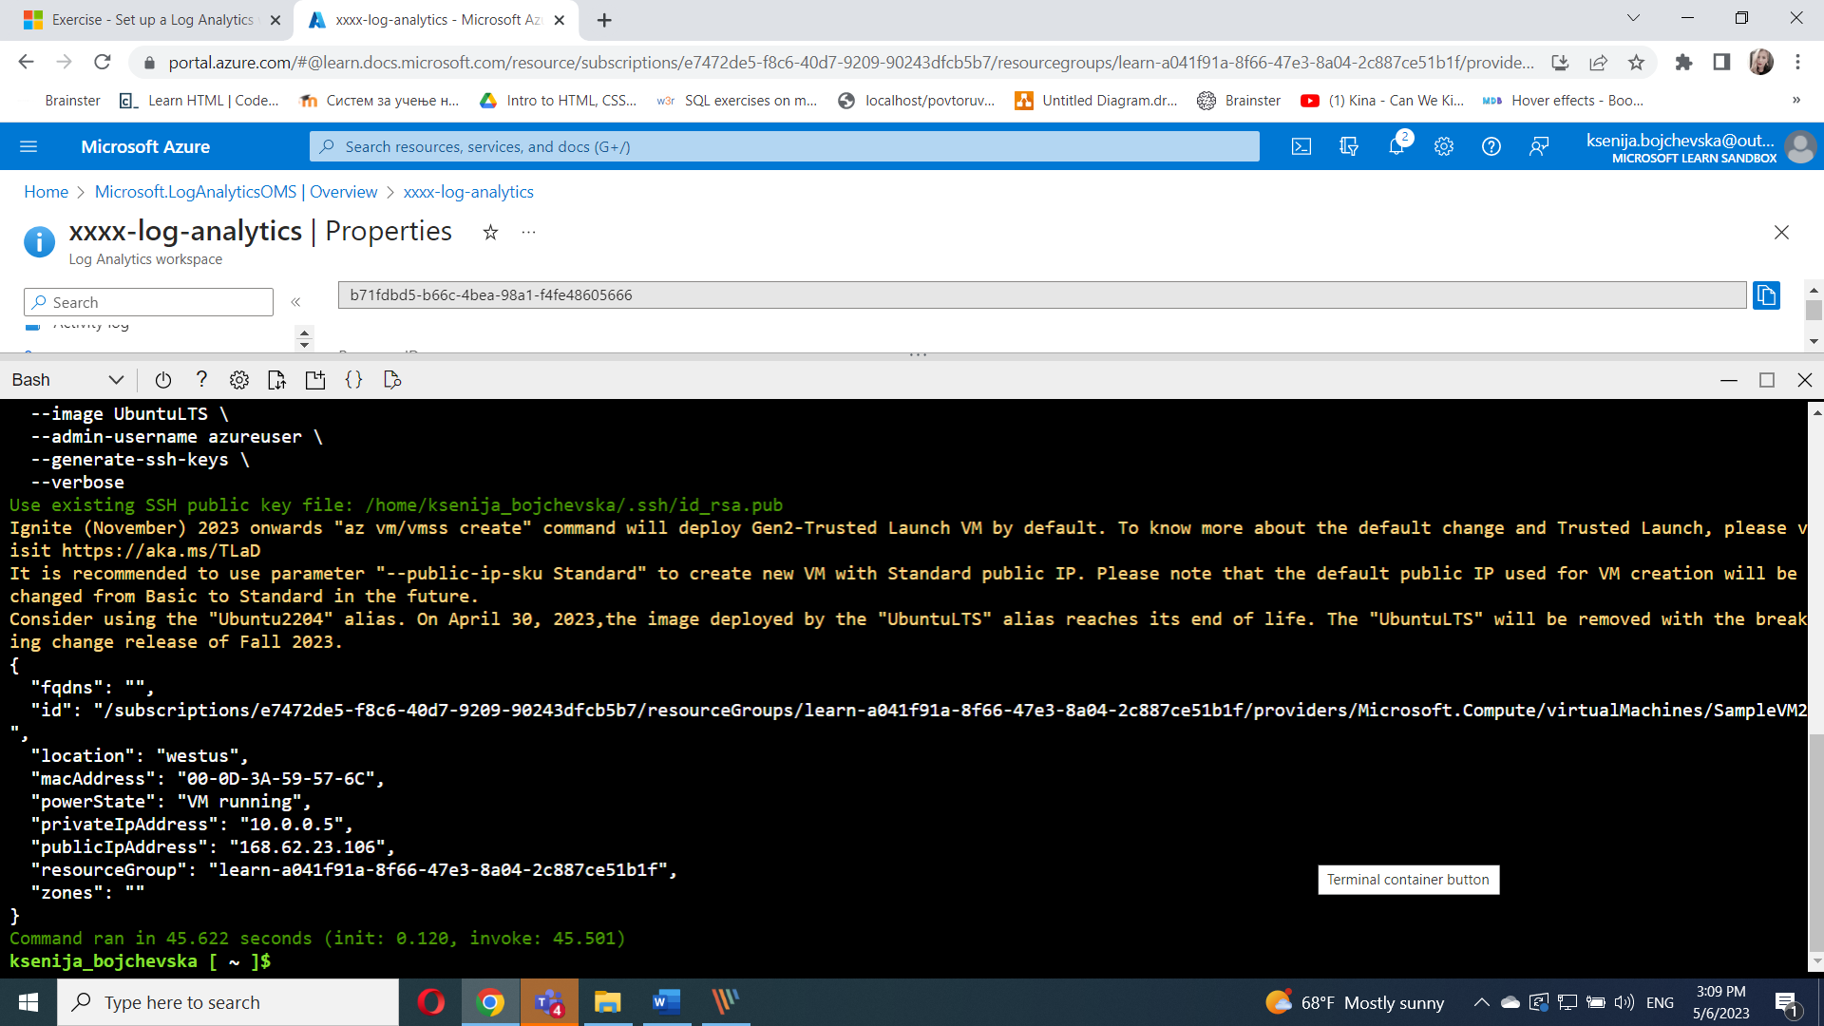

## Onboard virtual machines to Azure Monitor VM Insights

1. In the [Azure portal](https://portal.azure.com/learn.docs.microsoft.com), search for and select **Virtual machines**.

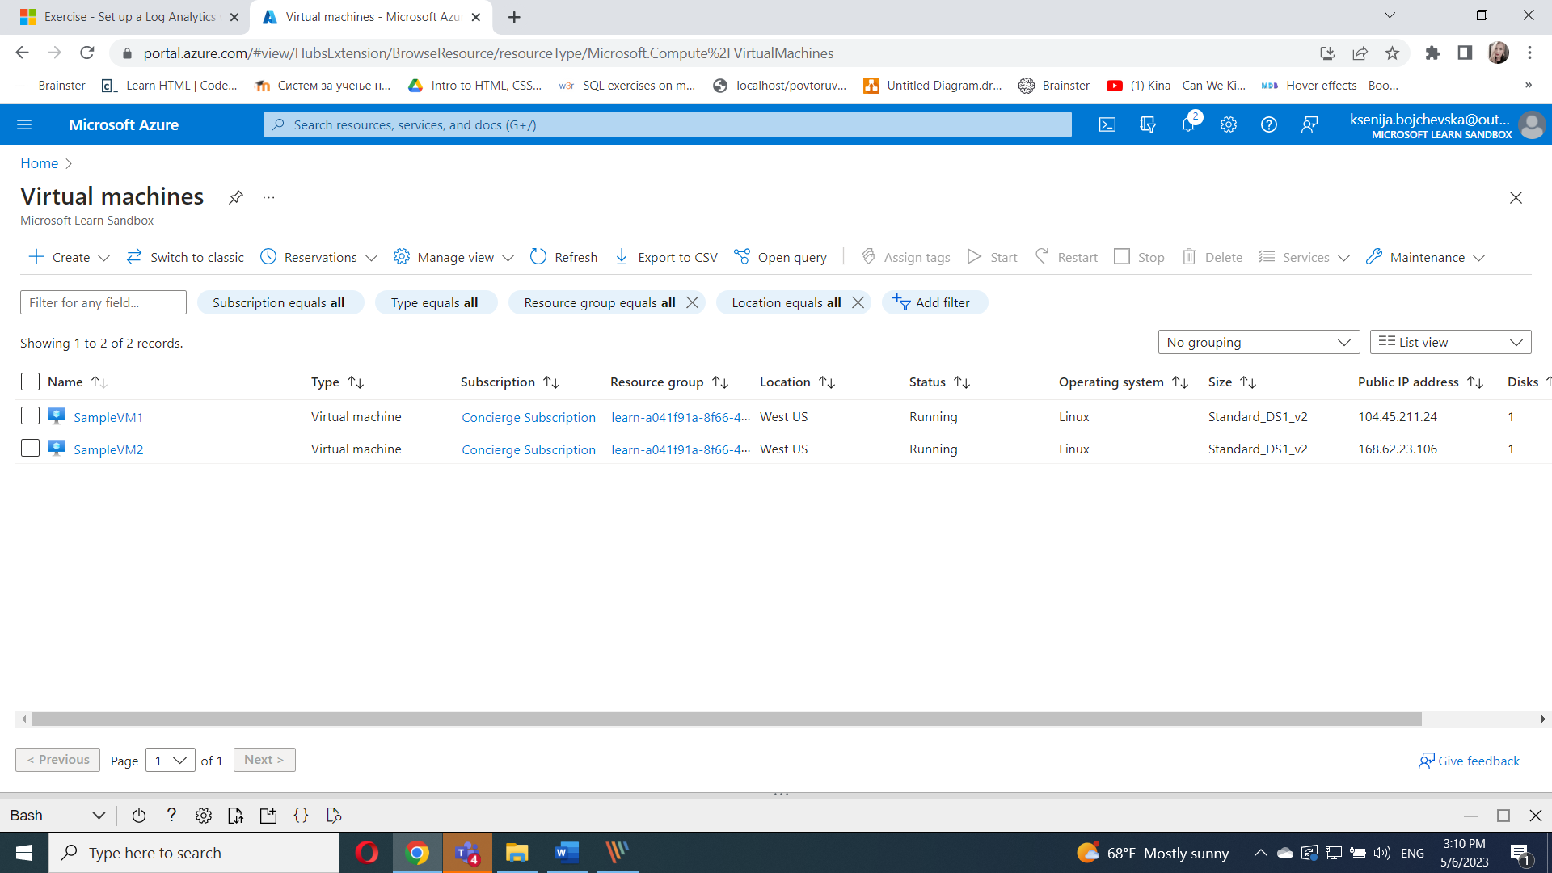

1. Select **SampleVM1**.

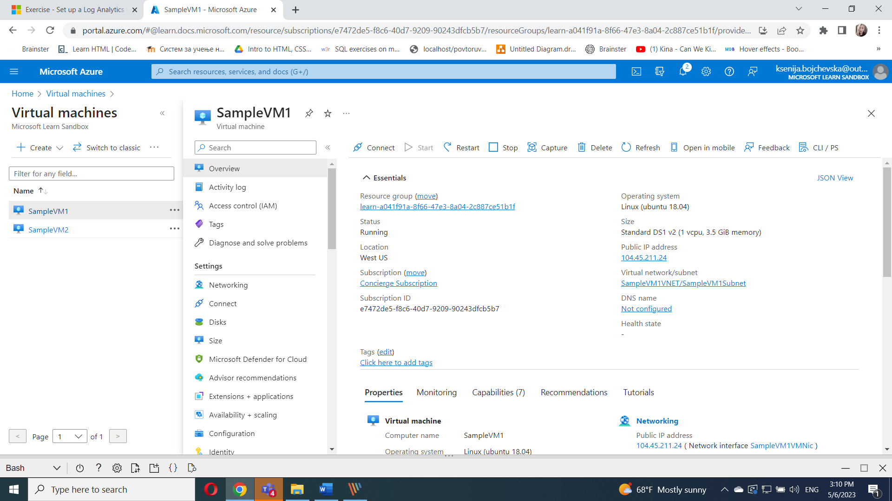

1. In the left menu under **Monitoring**, select **Insights** > **Enable**.
2. Select the radio button for **Log Analytics agent**, then select the Log Analytics workspace you created in the **Log Analytics workspaces** drop-down.
3. Select **Configure**.

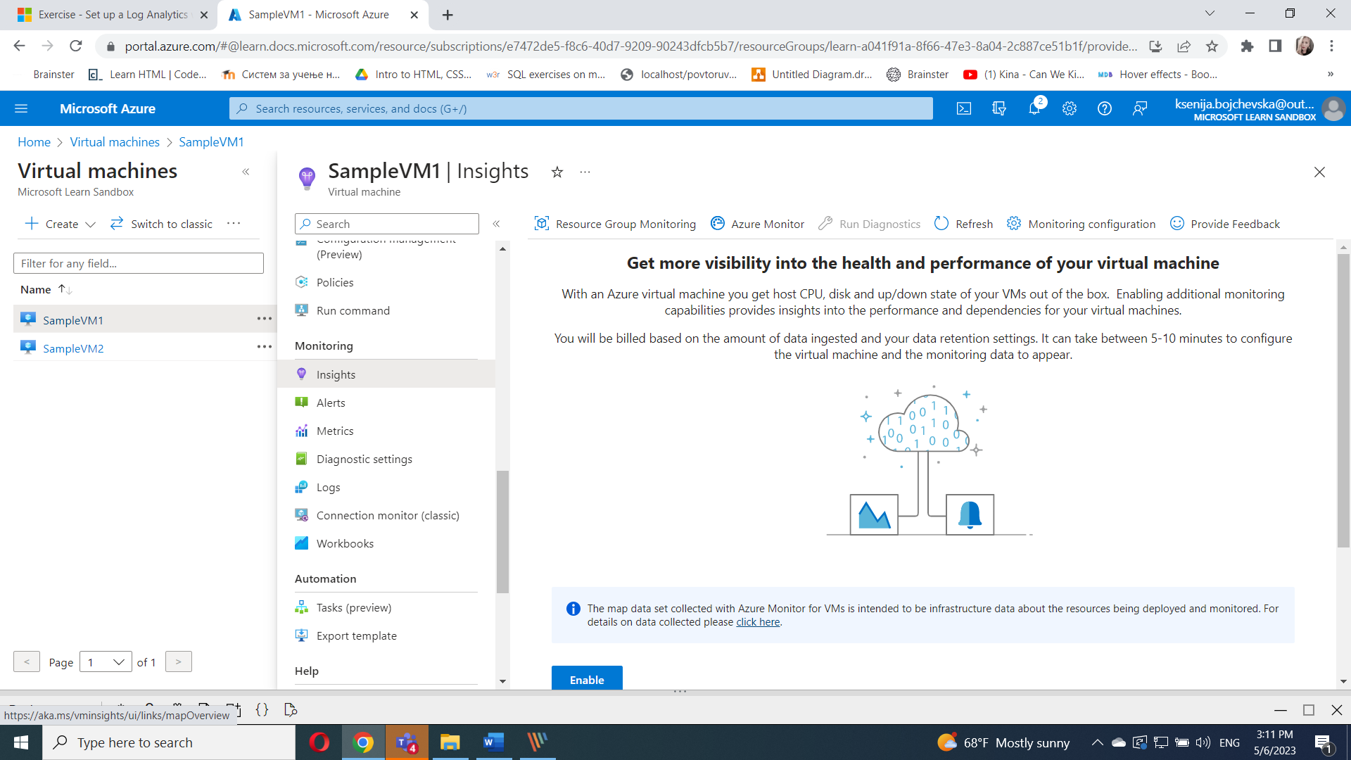

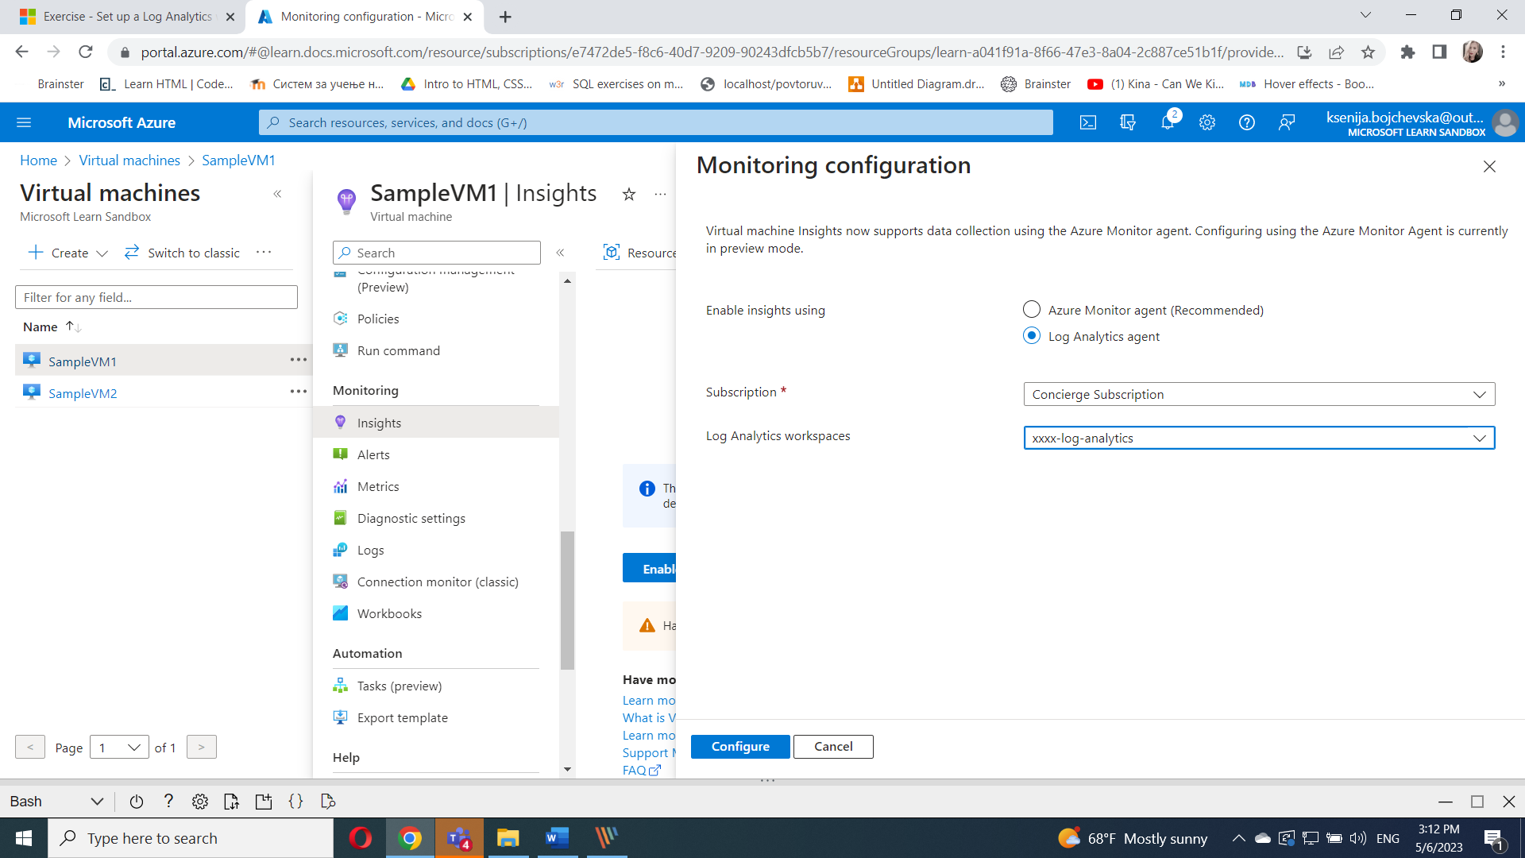

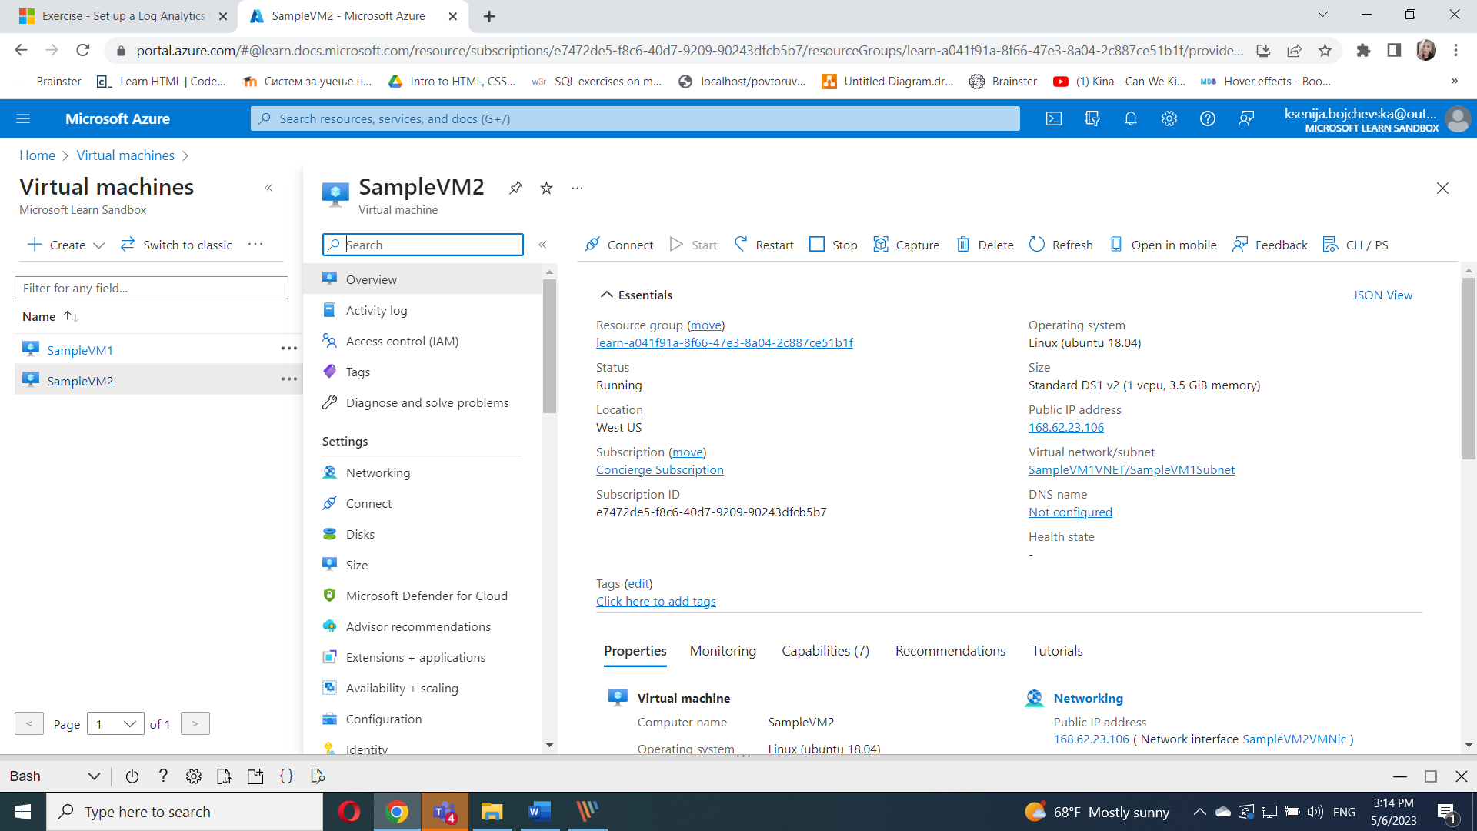

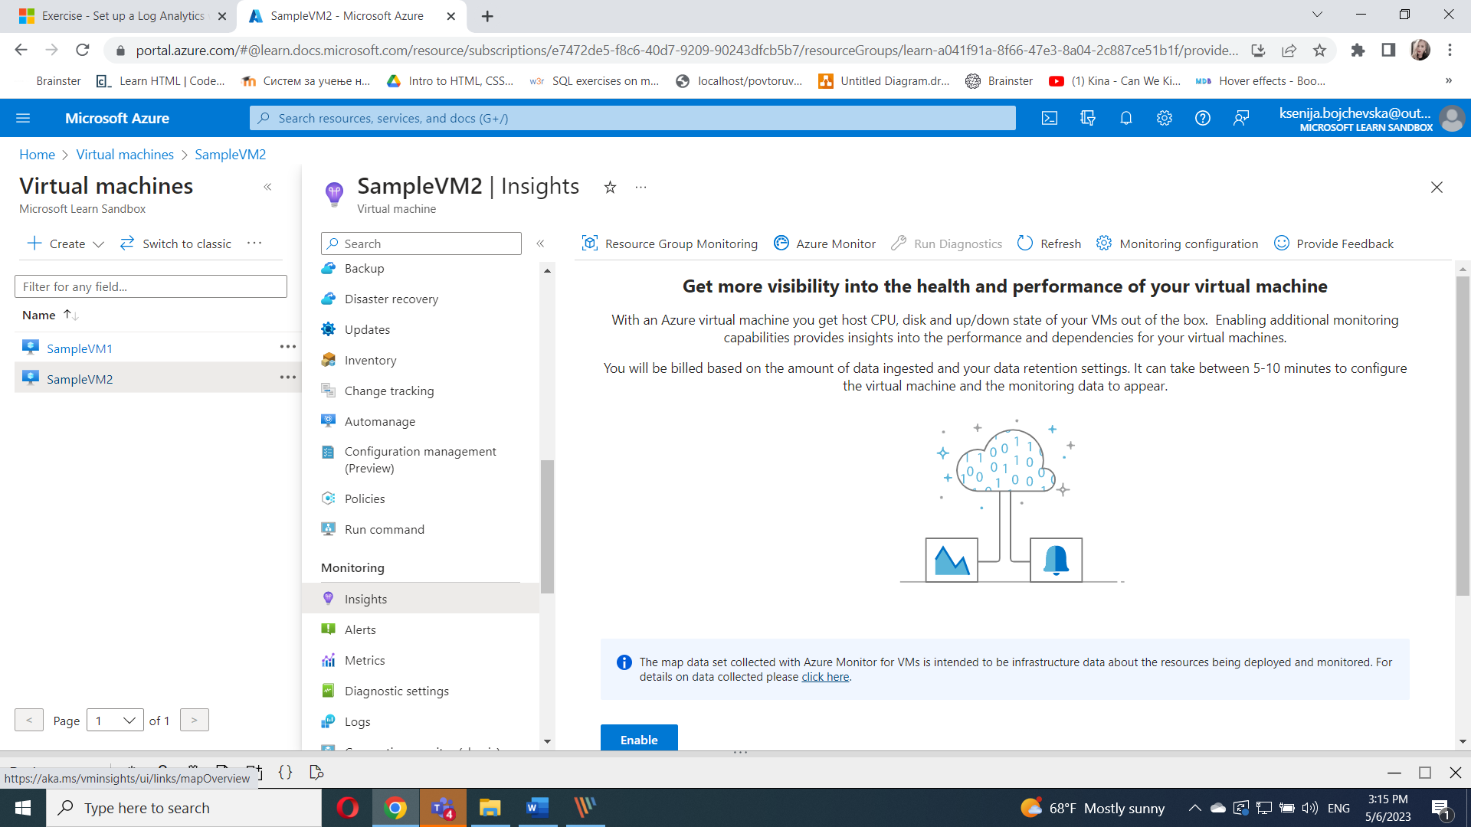

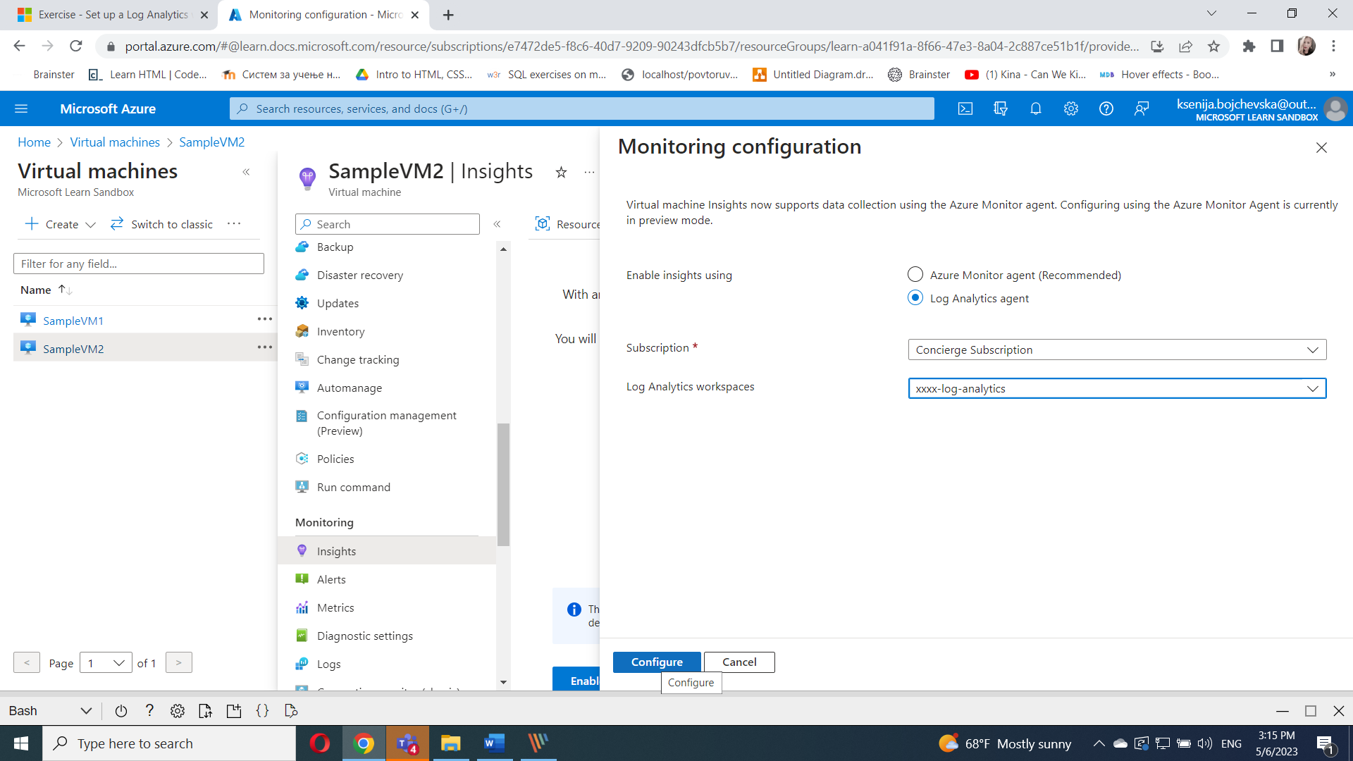

Review the map, which displays dependencies like processes running, ports open, connection details, health of the virtual machine, machine properties, and Azure virtual machine properties.

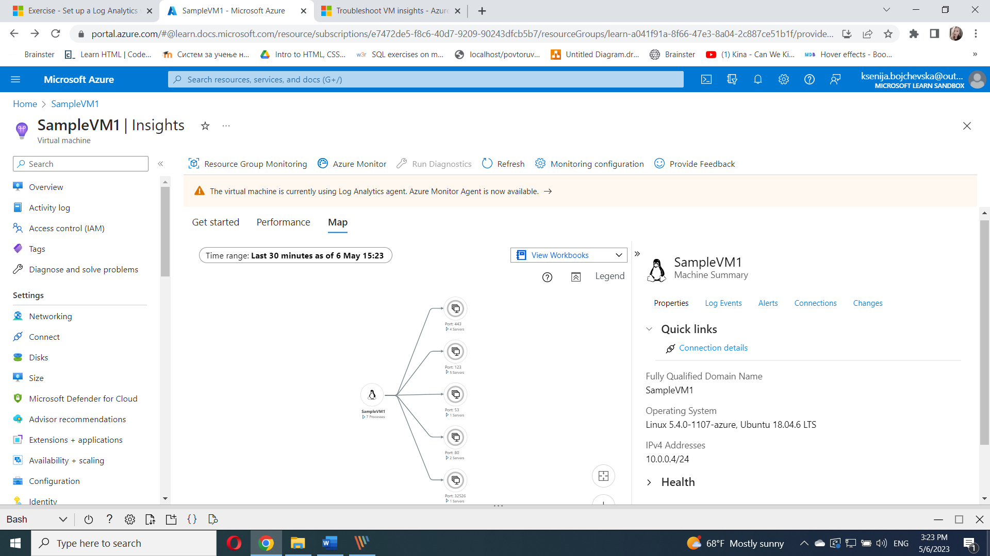

Select the **Performance** tab.

Explore the different graphs for:

* + Logical Disk Performance
  + CPU Utilization
  + Available Memory
  + Logical Disk IOPS
  + Logical Disk MB/s
  + Logical Disk Latency (ms)
  + Max Logical Disk Used %
  + Bytes Sent Rate
  + Bytes Received Rate

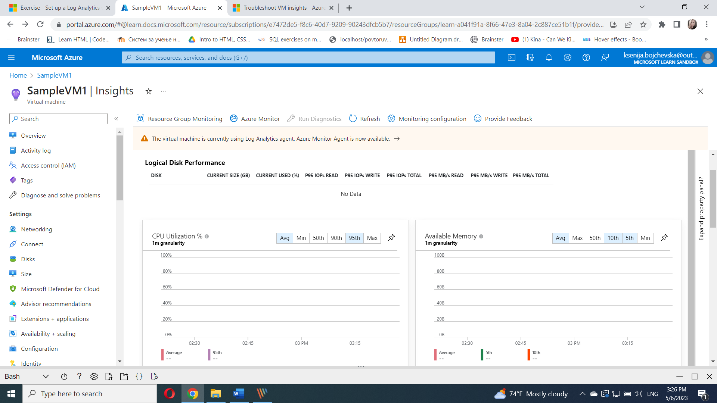

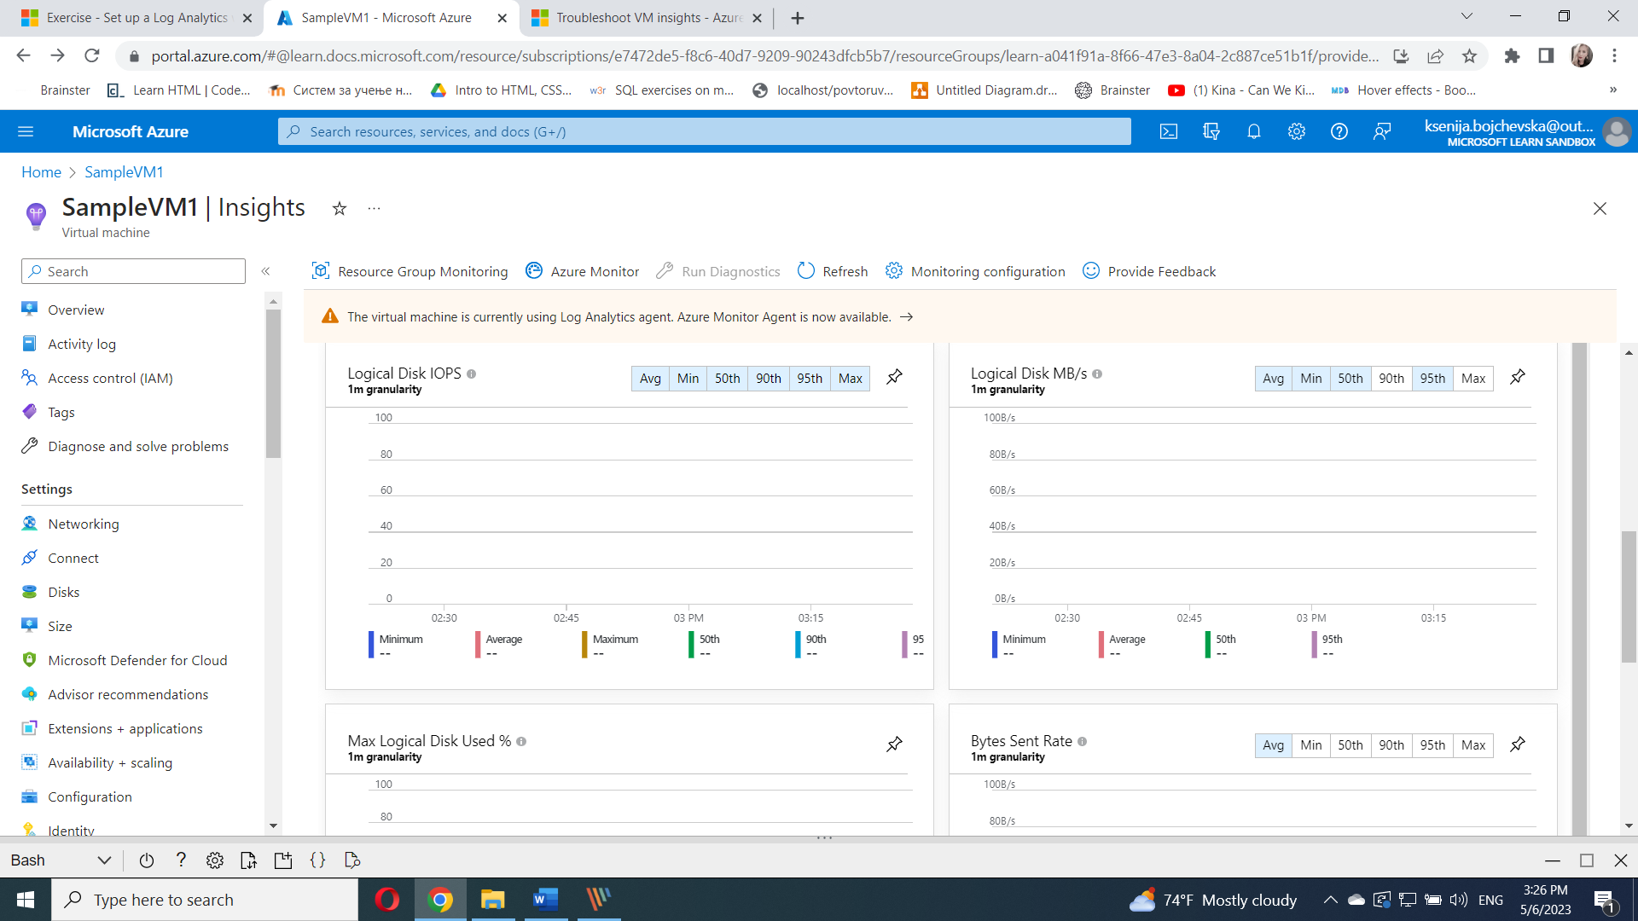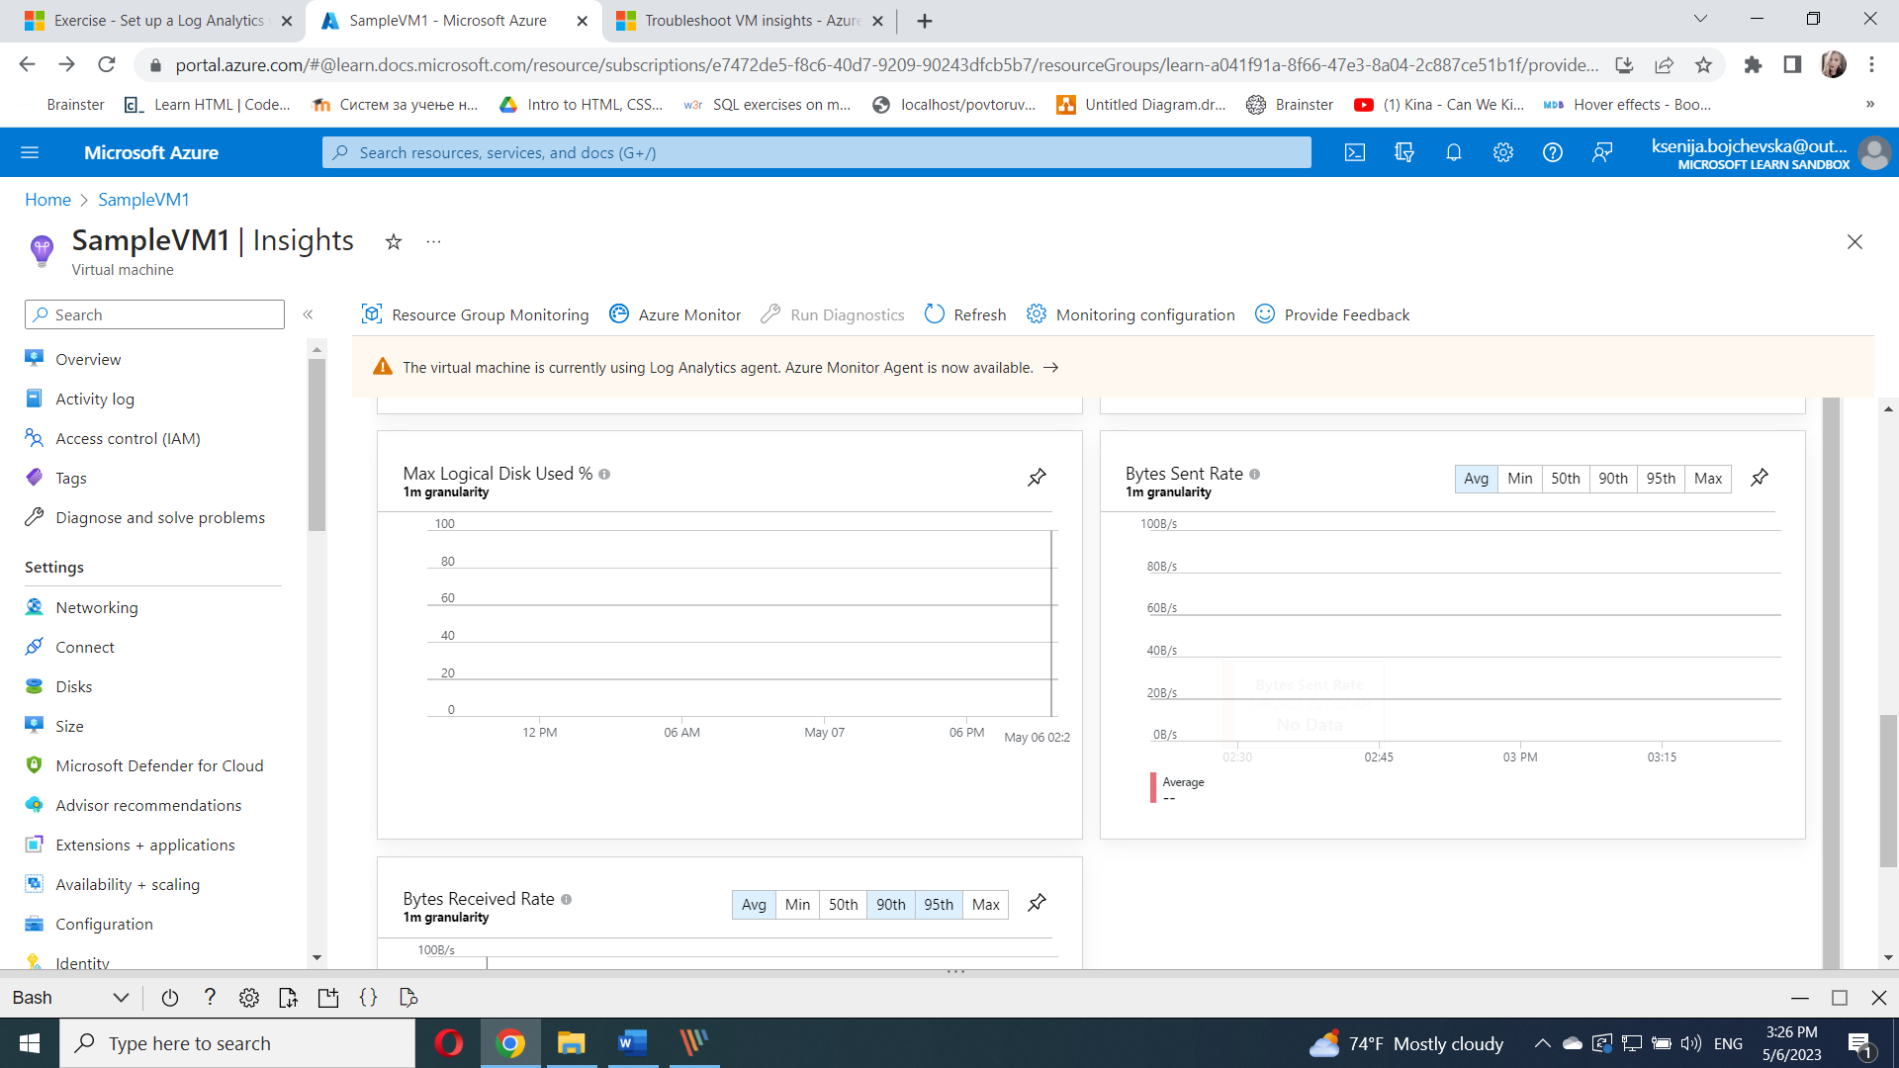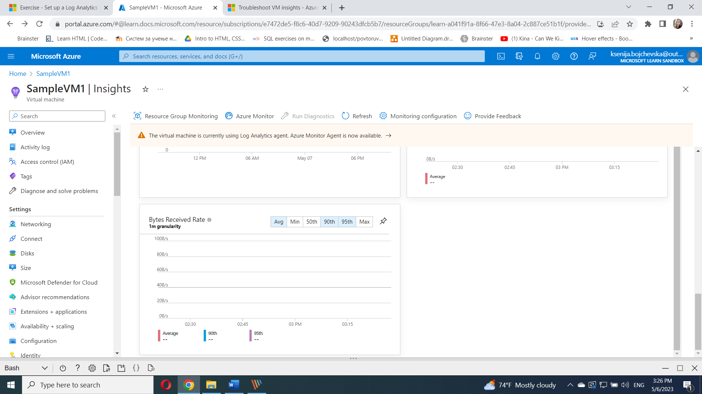

Select **Log Events**. You might need to expand the Property panel on the right.

Select the **InsightsMetrics** row in the table.

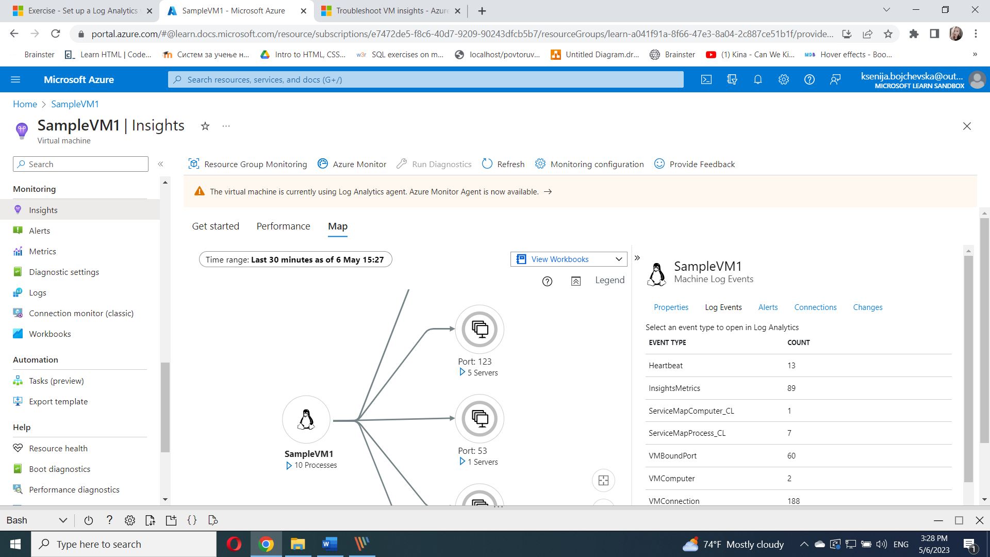

The logs section of a Log Analytics workspace opens with a prepopulated query showing the data being collected.

